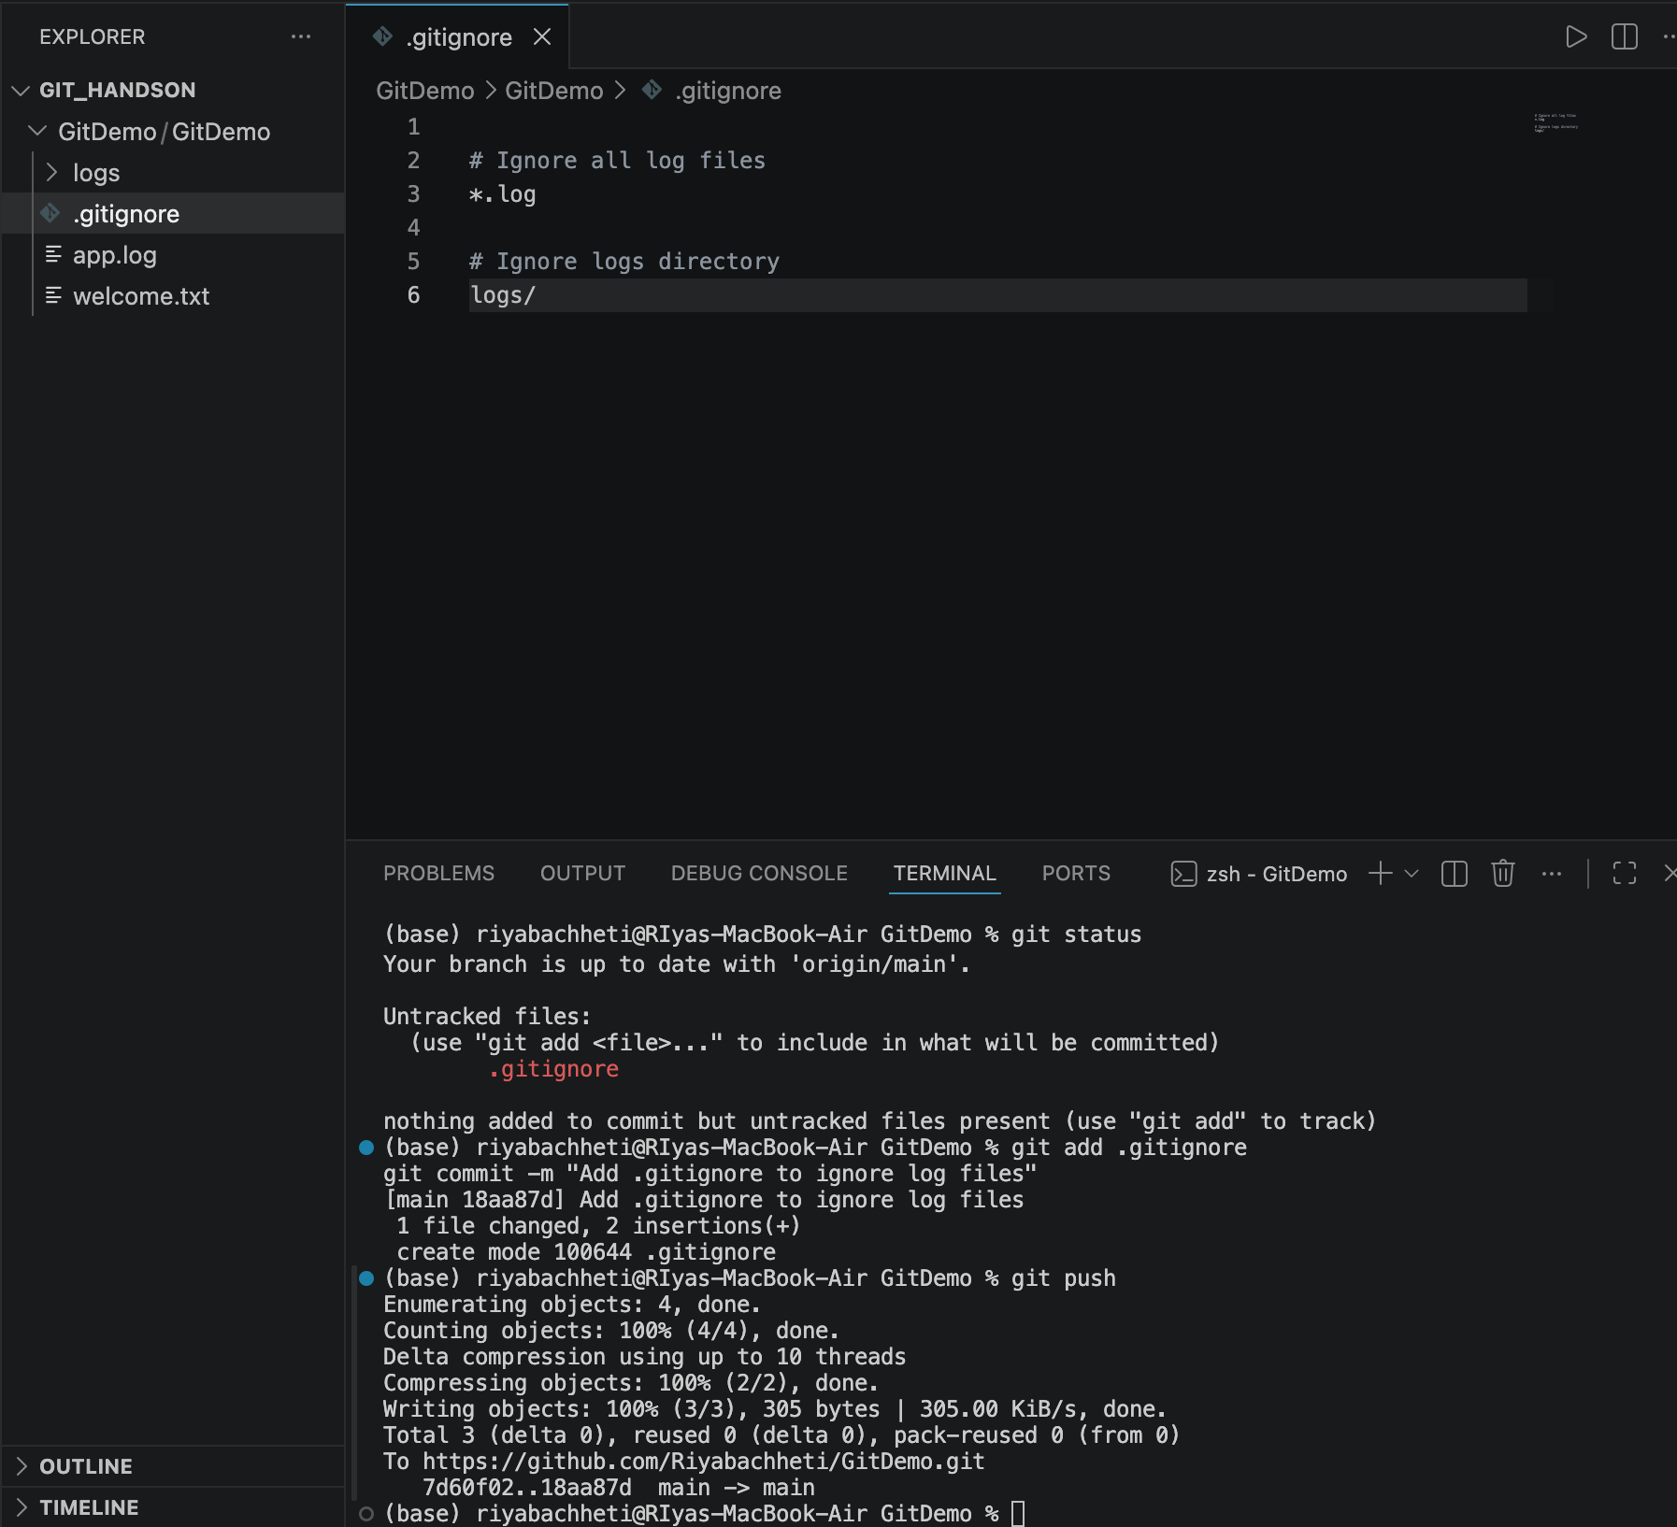

- Resulting github repo: https://github.com/Riyabachheti/GitDemo.git

